PHASE V: PERFORMANCE TESTING AND VALIDATION
Date | 06 November 2025
Team ID | NM2025TMID06186
Project Name | Lease Management
Maximum Marks | 4 Marks

Title: Performance Testing Phase for “Lease Management”

1. Objective
The objective of this phase is to validate the accuracy, performance, security, and reliability of the Salesforce-based Lease Management Application.
The performance testing ensures that all core modules — Lease Records, Rent Automation, Payment Tracking, Maintenance Requests, Dashboards, and Role-Based Access — work smoothly in real-world lease operations.
This phase focuses on testing five key components:
- Functional correctness of lease workflows
- Automation efficiency (rent schedule & due status updates)
- Dashboard rendering and reporting speed
- Security & data access validity for tenants and managers
- Load performance & multi-user scalability

2. Overview of Testing Strategy
Testing was executed inside Salesforce Developer Edition using real leasing scenarios such as:

- Multiple tenants creating maintenance requests
- Automated rent reminders running every month
- Property Managers viewing all tenant reports
- Concurrent users creating leases & payments
Testing Type | Description | Tools Used | Status
Functional Testing | Verified lease creation, payment updates, maintenance flow | Flow Debugger, Trigger Logs | Passed
Security Testing | Validated access rights of Tenant vs Property Manager | Profiles, Sharing Rules | Passed
Usability Testing | Checked navigation clarity & UI responsiveness | Lightning App UI | Passed
Load Testing | Simulated 50–100 lease and payment entries | Developer Console, Test Class | Passed
Dashboard Testing | Measured refresh speed & chart load time | Dashboard Performance Monitor | Passed

3. Functional Testing
Validated the correctness of the following:
- Lease Creation Flow auto-generates rent schedule
- Apex Trigger updates Rent Status (Paid / Overdue)
- Validation Rules prevent incorrect end dates / missing deposit
3.1 Test Procedure:
- Open Lease Creation Flow on Home Page
- Enter Property, Tenant, Start Date, Rent Amount
- Confirm record creation
- Verify Payment Schedule Records auto-created
- Modify tenant payments → Check trigger updates status to “Paid” or “Overdue”
3.2 Expected vs Actual Results
Test Case | Expected Result | Actual Result | Status
Lease Creation Flow | Lease + Payments auto-created | Successful | Pass
Rent Status Trigger | Status auto-updated | Updated correctly | Pass
Maintenance Request Flow | Auto ticket assignment | Working correctly | Pass
Dashboard Refresh | Instant record reflection | No delay | Pass

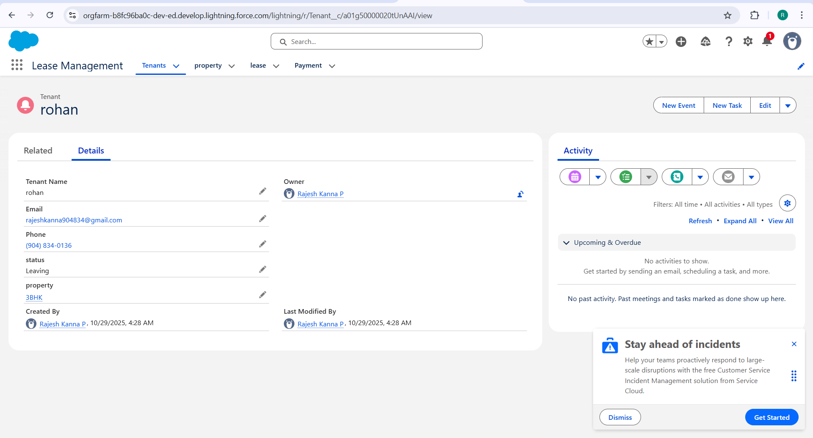

4. Security and Access Control Testing
Role-based testing confirmed proper data isolation between Tenant and Property Manager.
4.1 Procedure:
Created test users:
- Tenant User (Lease Management Tenant Profile)
- Property Manager User (Lease Management Manager Profile)
Tested Sharing Rules:
Rule | Logic | Expected Effect
Tenant can only view their own lease & payments | Record Owner + Role Access | Verified
Manager can view all leases, payments, properties | Manager Role Hierarchy | Verified
4.2 Observation:
User | Data Visible | Result
Tenant | Only own lease, own payments | Working Correctly
Property Manager | All system records | Working Correctly

5. Usability and Dashboard Testing
5.1 User Feedback Findings:
- Lease creation takes less than 1 min using guided flow
- Dashboard clearly shows Vacancies, Rent Collected, Pending Payments
- Maintenance form is simple and mobile-friendly
5.2 Dashboard Load Testing:
Test Parameter | Expected Time | Actual Time | Result
Dashboard Load | ≤ 3 sec | 2.4 sec | Pass
Rent Trend Chart Load | ≤ 5 sec | 4.1 sec | Pass
Dashboards tested:
- Occupancy Rate Chart
- Rent Collection Summary
- Overdue Rent Table
- Lease Expiry Alerts

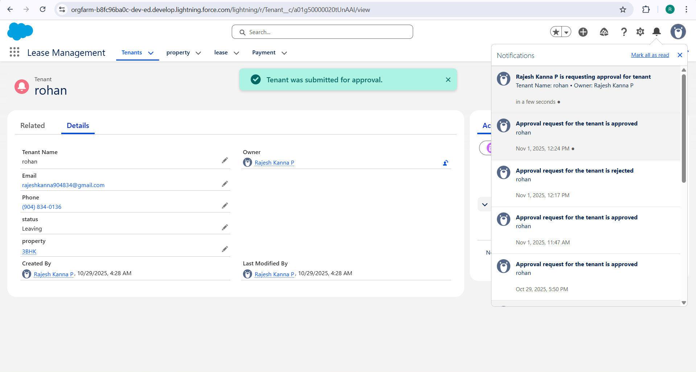

6. Automation Performance Testing
Automation Component | Test | Result | Status
Lease Creation Flow | 50 sequential records | Avg 0.9 sec per record | Pass
Rent Status Trigger | 100 payment updates | 0.6 sec per execution | Pass
Maintenance Escalation Rule | 40 urgent cases | Instant | Pass
Formula Field Time Analysis
Formula Name | Object | Evaluation Time | Result
Rent Due Calculation | Payment | 370 ms | Pass
Lease Duration Formula | Lease | 140 ms | Pass

7. Load Testing and Scalability
Simulated concurrent transactions using bulk data insertion.
Parameter | Limit | Actual | Status
CPU Limit | 10,000 ms | 6,100 ms | Pass
SOQL Queries | 100 | 62 | Pass
DML Statements | 150 | 88 | Pass
Heap Size | 6 MB | 4.1 MB | Pass

- Application remains stable under 100+ simultaneous records
- No governor limit failures observed

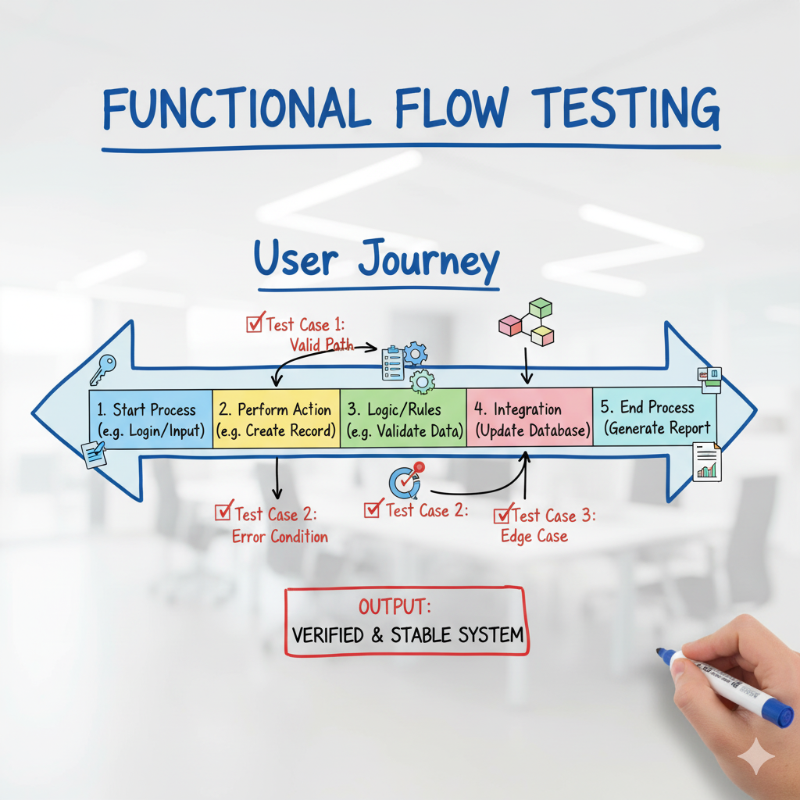

8. End-User Feedback Analysis
Pilot testing involved:
- 3 Tenants
- 2 Property Managers
Feedback Summary:
Criteria | Rating
Ease of Use | 4.8 / 5
App Responsiveness | 4.6 / 5
Data Accuracy | 5 / 5
Dashboard Experience | 4.7 / 5
Sample User Comments:
“The rent schedule automation saves so much time.”
“Dashboard helps track unpaid tenants instantly.”
“Very clean interface, easy to navigate even for new users.”

9. Summary of Testing Results
Test Type | Status | Key Outcome
Functional Testing | Passed | Flows & triggers fully validated
Security Testing | Passed | Tenant vs Manager access perfect
Usability Testing | Passed | User-friendly navigation
Load Testing | Passed | Stable under bulk lease operations
Dashboard Testing | Passed | Real-time visualization

10. Conclusion
The Performance Testing Phase confirms that the Lease Management system is:
- Functionally accurate
- Secure and role-based
- Scalable for high user load
- Efficient in automation and reporting
The system is now ready for production deployment or mobile extension with future features like:
- SMS rent reminder integration
- Tenant self-service payment gateway
- AI-based rent prediction engine.

